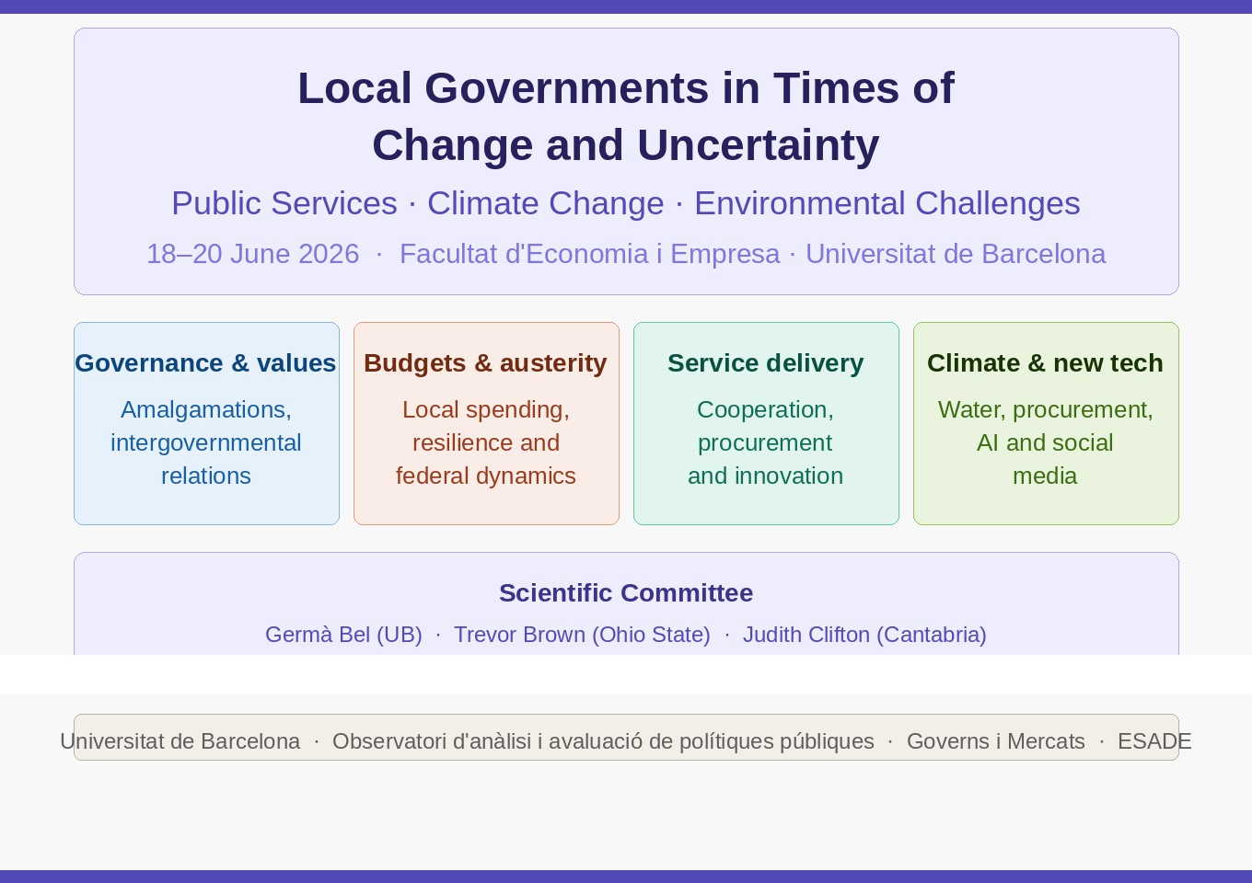
Marc Esteve (UCL-ESADE) · Raymond Gradus (VU Amsterdam) · Mildred Warner (Cornell)

Organizing committee: Daniel Albalate (Chair, UB), Germà Bel (UB), Melike Bitlis-Bush (UC Santa Barbara), Laia Maynou (UB), Annette Slyke (Indiana U.), Silvia Yanguas (UB)

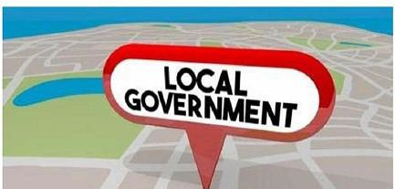







Local Governments in Times of Change and Uncertainty: Public Services, Climate Change and Environmental Challenges

Thursday 18 June 2026

Venue: Facultat d’Economia i Empresa (U. de Barcelona). SALA DE GRAUS
Av. Diagonal 690 (or John Keynes 1-11).

14h30. Registration opens

15h00-15h15: Opening remarks
15h15-16h00. Values, intergovernmental relations and collaboration
Chair: Marc Esteve (UCL)
Municipal amalgamations as a threat to democracy and the principles of local self-government: small municipalities' resistance to the "big is beautiful" paradigm
Erlingsson, Gissur (Linköping U.) & Jörgen Ödalen (Linköping U.).
Does vertical consolidation improve local public service performance?
Alonso, Jose M. (U. Cantabria) & Rhys Andrews (Cardiff U.)

16h00-16h45. Crime, punishment and local governance
Chair: Mattia Casula (U. di Bologna)
Mafia infiltration, local governments and public policies
Michele Giuranno (U. del Salento) & Debora Assisi (U. del Salento) & Diego Ravenda (TBS Business School) & Felice Russo (U. del Salento)
Analysis of fees and fines for residents and nonresidents: impacts for social and economic inequity
Austin M. Aldag, (U Alabama Birmingham) & Peter A. Jones (U Alabama Birmingham).

16h45-17h15: Coffee Break

17h15-18h15. Local public spending and austerity
Chair: Juri Hwang (Cornell U.)
The politics of local spending: municipal budget responses to federal election results
Lorenzo Catalano (K.U. Leuven) & Kristof De Witte (K.U. Leuven).
Resilient local budgeting in times of change.
Tjerk Budding (Vrije U. Amsterdam), Raymond Gradus (Vrije U. Amsterdam) & André Mol (Vrije U. Amsterdam).
Fungible Budgets: An analysis of US local government project cancellations in early 2025.
Zijing Zhao (Cornell U.) & Mildred Warner (Cornell U.).

Friday 19 June 2026

9h30-10h30. Public services delivery, organizational choices and effects
Chair: Amir Hefetz (DGR&SC, Holon).
Intermunicipal cooperation and utility strategies: to cooperate or not to cooperate?
Emilien Macault (U. de Lorraine) & Alexandre Mayol (U. de Lille).
Still changing after all these years: A dynamic analysis of Portuguese local government Service Delivery Choices (1999-2025).
António Tavares (U. de Minho) & Pedro Camões (U. de Aveiro).
Shared Bureaucracy and Local Government Performance: Evidence from Planning Controls in England.
Han Wang (U. Southampton; LSE); Thomas Elston (U. Oxford).

10h30-11h15. Innovations in delivery and procurement of services
Chair: Yael Heifetz (Hebrew U. of Jerusalem)
Political ideology and administrative innovation: evidence from municipal service delivery in Catalonia
Joël Bühler (U. de Barcelona), Esther Pano (U. de Barcelona) & Marianna Sebő (U. Politècnica
de Catalunya)
Changing mindsets in local government contracting: evidence from a national-scale RCT on relational contracting training
Ole Helby Petersen (Roskilde U.), Lena Brogaard (Roskilde U.), Matthew Potoski (U.C. Santa Barbara), Nicholas Buhmann-Holmes (Lund U.).

11h15h-11h45: Coffee break

11h45-12h30. Managing risks from climate change
Chair: Justine Le Floch (U. Paris I-Sorbonne)
The strategy of the horizons: the role of underinvestment in municipal water networks during summer drought challenges
David Cromelynk (U. de Brest); Alexandre Mayol (U. de Lille); Simon Porcher (U. Dauphine); Stéphane Saussier (U. Paris I).
Addressing climate change through public procurement: A big data and machine learning approach.
Bjarke Lund-Sørensen (Roskilde U); Lena Brogaard (Roskilde U) & Ole H Petersen (Roskilde U).

12h30-13h30: ‘Meet the editor’ session
Chair: Trevor Brown (Ohio State U.)
Claudia Avellaneda (Indiana U.). Local Governments Studies.
Judith Clifton (U. de Cantabria). Journal of Economic Policy Reform.
Ole. H. Petersen (Roskilde U). Journal of Public Administration Research and Theory.
Matthew Potoski (U.C. Santa Barbara). Journal of Policy Analysis and Management &
International Public Management Journal.

13h30-15h00: Lunch time (free).

15h00-16h00: Challenges for accessibility and equity in local services
Chair: Claudia Avellaneda (Indiana U.)
A Public Value Framework for Collaborative Governance: Legitimating Social Equity Through Community-Based Outcomes
Silvestre, Hugo (UNILAB, Brazil); Eduardo Grin (FGV, Brazil) & Aldenísio Correia (UNILAB, Brazil)
Do Crises Motivate Change? Did local government services for aging increase after the pandemic?
Mildred Warner (Cornell U.), Hongtao Huang (Cornell U.) & Xue Zhang (Penn State U.).
Privately financed PPPs for social and affordable housing: A review of the Irish experience
Dónal Palcic (U. of Limerick) & Eoin Reeves (U. of Limerick)

16h00-16h45: New technologies and approaches: analysis and policy implementation
Chair: David van Slyke (Syracuse U.)
Does professionalization in governments’ social media use increase citizens’ online engagement?
– evidence from municipalities in Poland
Monika Banaszewska (U.E.W Poznainu); Ivo Bischoff (U. Kassel); Małgorzata M. Hybka (U.E.W Poznainu); Waldemar Rydzak (U.E.W Poznainu); Jacek Trębecki (U.E.W Poznainu) & Aleksandra Wimberger (U. Kassel)
How AI can improve state & local infrastructure delivery: A practical framework using a large post-WWII project dataset
Richard Geddes (Cornell U.) & Saurabh Mishra (Taiyō.AI).

Saturday 20 June 2026
9h30-12:30am: Network meeting to discuss the incorporation of the Workshop’s contributions to the results of the project Mobility and transport policies: Effects on climate change, sustainability and health. Ministry of Science and Innovation (PID2022-138866OB-I00). 2023-26.

12h30-13h00: Concluding remarks

